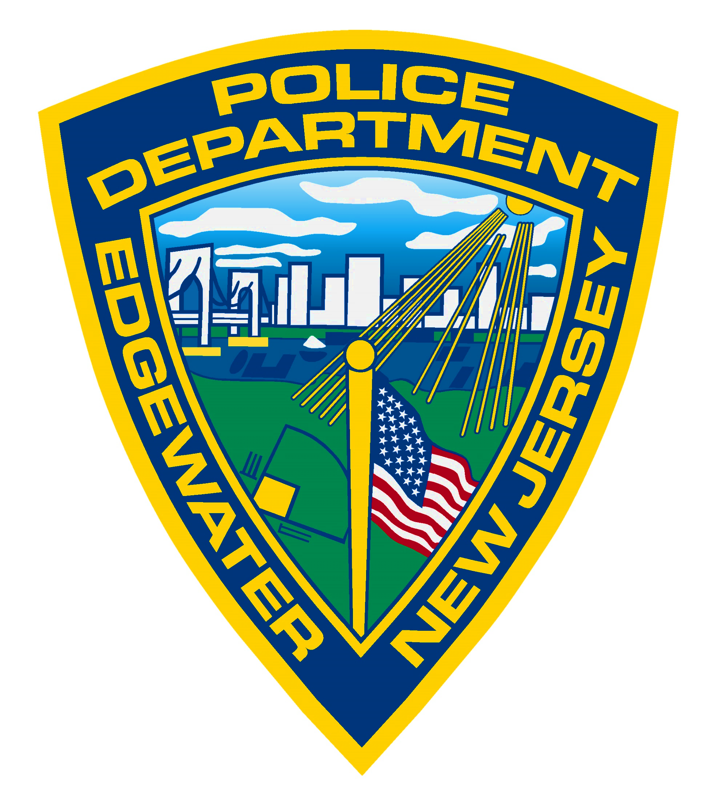
EDGEWATER NIGHT OUT
GET TO KNOW YOUR COMMUNITY

THURSDAY
AUGUST 8th
6:00-8:30PM
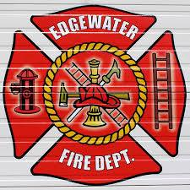
-LIVE MUSIC
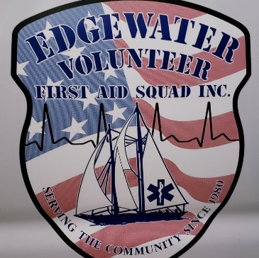
-DEMONSTRATIONS
-CHILDRENS ACTIVITIES
-FOOD AND DRINKS



AT
VETERANS FIELD
JOIN US FOR A FUN NIGHT OUT WITH EDGEWATER’S EMERGENCY SERVICES
AND THE EDGEWATER RECREATION DEPARTMENT

